Floriade Accessibility Guide 2026


About Easy Read

Easy Read uses images and simple words to explain things.


We will bold and explain words that may be new or hard.
Easy Read has the main information.
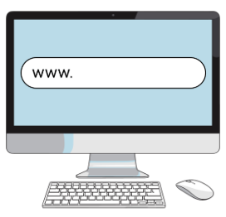
You can find the full details on our website https://floriadeaustralia.com/

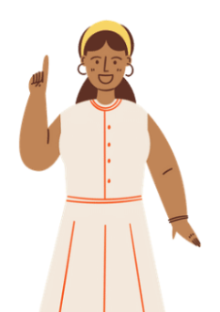
You can get someone to help you read this book.

About this book

This book is from the ACT Government. When the book says we it means the ACT Government.
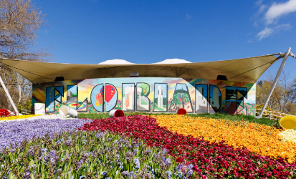
This book is about Floriade and NightFest.
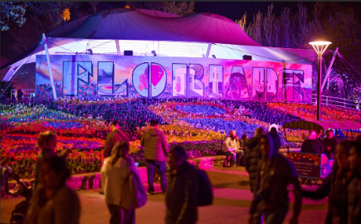
Floriade is on at daytime.
NightFest is on at night time.

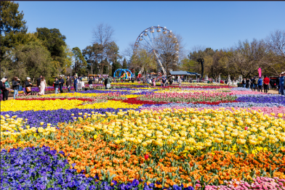
About Floriade
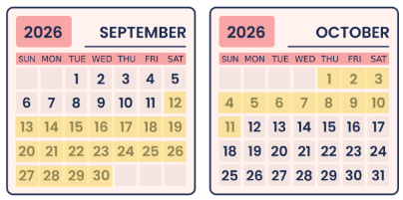
Floriade is a big flower event in Canberra.

Floriade is on from 12 September to 11 October 2026.
At Floriade you can see flower gardens with different colours.
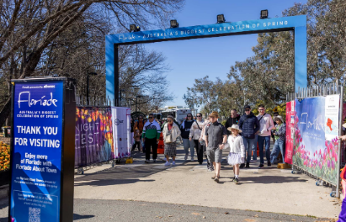
Floriade entry gates are at:
- Regatta Point
- Parkes Way footbridge
- Ferry Gate
- Nerang Pool.
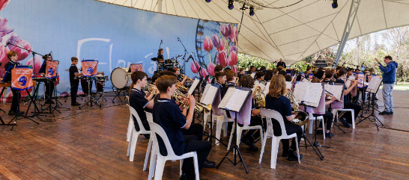
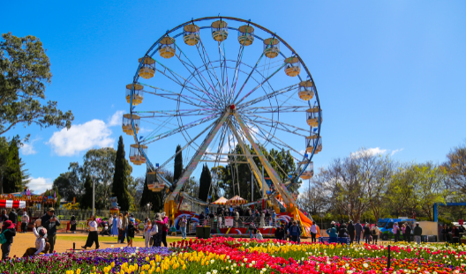
At Floriade
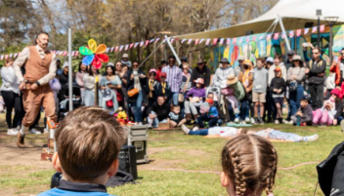
you can hear live music
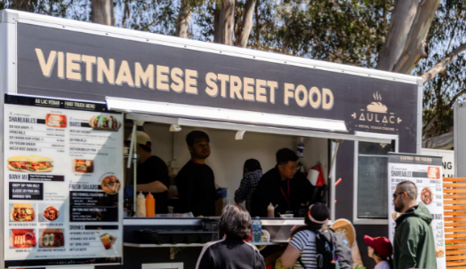
you can watch live shows
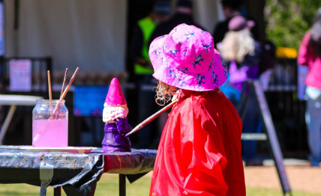
you can buy food and drinks
you can do activities
you can go on rides.

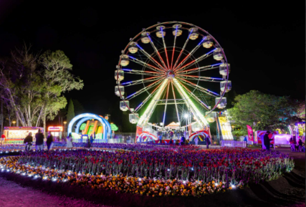
About NightFest
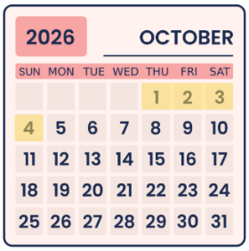
NightFest is an event that is part of Floriade.
NightFest is on from the 1st to the 4th of October.
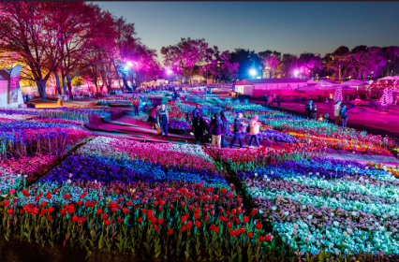
At NightFest you can see coloured lights on the flower gardens at night.
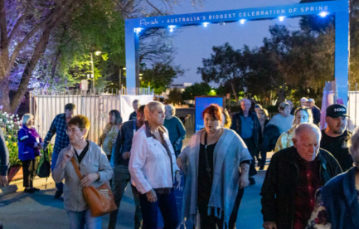
NightFest entry gates are at:
- Regatta Point
- Parkes Way footbridge
- Ferry Gate.

At NightFest you can use the accessible entry lane if you need.
You can talk to the staff at the gate about your entry needs.
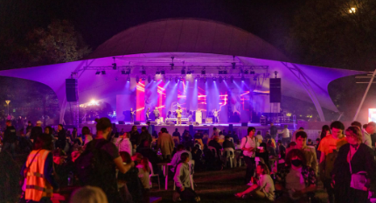
At NightFest
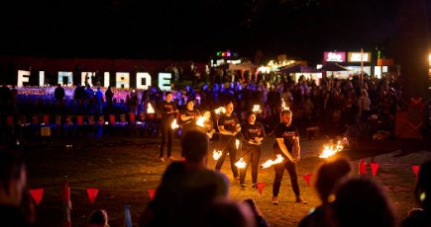
you can hear live music
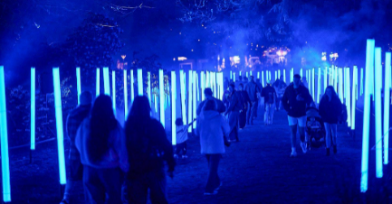
you can watch live shows
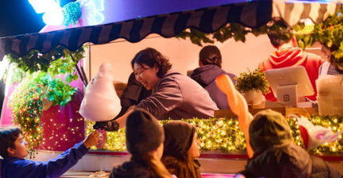
you can see light displays
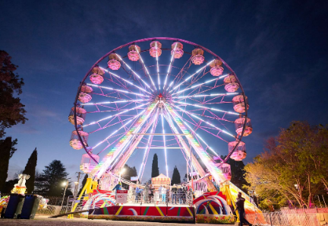
you can buy food and drinks
you can go on rides.

Getting to Floriade and NightFest
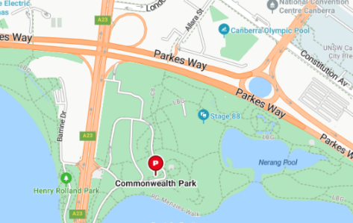
Floriade and NightFest are at Commonwealth Park in Canberra.
In this part of the guide the information is the same for both events.

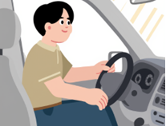
Parking
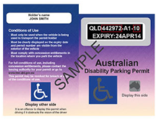
You can drive your car and park nearby.

There is parking for people with disability permits.
You can see where to park on the Floriade website: https://floriadeaustralia.com/floriade-maps/

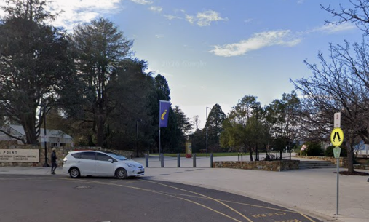
Drop off and pick up points
There is a drop off and pickup point at Regatta Point.
It is off Commonwealth Avenue.
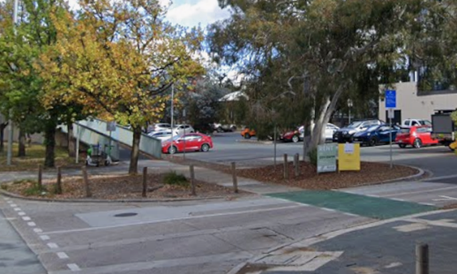
There is a drop off and pick up point at the Parkes Way footbridge.
It is off Allara Street. You need to walk over the footbridge.
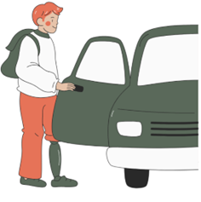
At these points:
- You can get dropped off by
your driver
- You can get picked up by
your driver

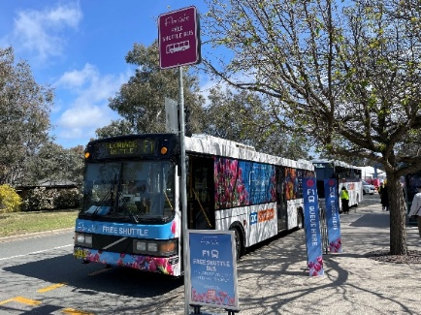
Floriade Shuttle Bus
You can catch the shuttle bus to Floriade.
The shuttle bus is free.
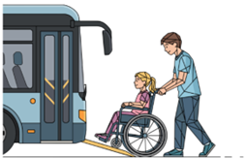
The shuttle bus
- has an accessibility ramp
- has a low, flat floor
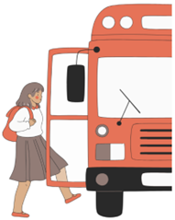
The shuttle bus can pick you up from and drop you off in:
- City centre, Civic
- National Triangle, Parkes
- Floriade, Regatta Point gate

You can see the shuttle bus times and map on the website: https://floriadeaustralia.com/getting-to-floriade/

Floriade Weekend Express Bus
You can catch the weekend express bus to Floriade.
The weekend express bus is free.
The weekend express bus
- has an accessibility ramp
- has a low, flat floor
The weekend express bus goes to
and from:
- Woden
- Belconnen
- Tuggeranong
- Floriade at Regatta Point Gate
You can see the weekend express bus times and map on the website: https://floriadeaustralia.com/getting-to-floriade/

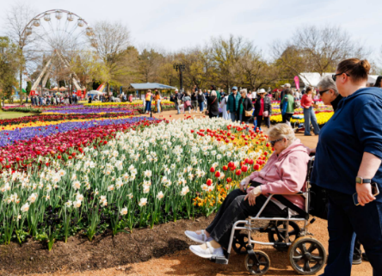
Getting Around Floriade
You can walk around Floriade to see the flowers.
Some of the paths are paved.
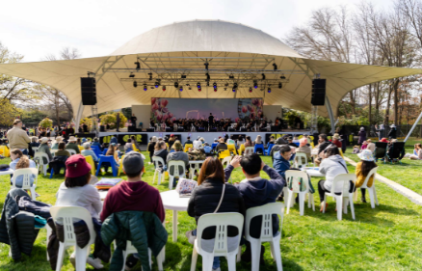
Some of the paths are gravel.
The food and music areas are on grass.

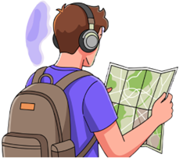
Floriade Maps
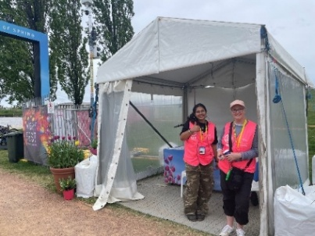
You can use a map to find things at Floriade.
You can get a map from the volunteer tent at each gate.
All volunteers at Floriade wear pink vests.
You can see the Floriade map on the website: https://floriadeaustralia.com/floriade-maps/

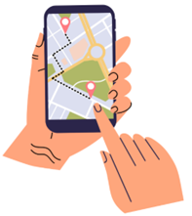
Interactive Maps
You can use a map called BindiMaps.

You will find BindiMaps on the website: https://floriadeaustralia.com/getting-to-floriade/
You can use BindiMaps to plan your visit from home.
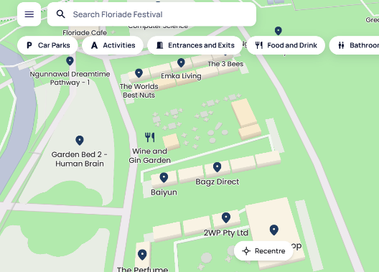
You can use BindiMaps to find
- flower gardens
- food areas
- parking
- toilets
- paths that are easy to move on.

You can choose different languages on BindiMaps.

How we support you at Floriade

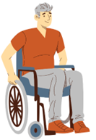

Mobility Hire
- You can borrow a wheelchair
- You can borrow a mobility scooter
You can book by
- email scooters@netspeed.com.au
- text message to 0403 242 584

Accessible Toilets
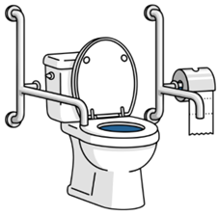
There are accessible toilets with
- handrails
- swinging doors
You can find the toilets on the map on the website: https://floriadeaustralia.com/floriade-maps/

Changing Places Facility
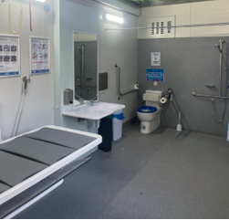
There is a Changing Places facility at Floriade.
A Changing Places facility
- is for people who need help to use the toilet
- has more space to move around
- has items to help people use
the toilet.
You can find the Changing Places facility on the map on the website: https://floriadeaustralia.com/floriade-maps/


Sensory Space
There is a sensory space at Floriade.
It is a calm space to sit and rest.
You can find the Sensory Space on the map on the website: https://floriadeaustralia.com/floriade-maps/


Sensory Hour
Sensory hour is from 9:30am to 10:30am on weekdays at Floriade.

It does not run on public holidays.

During sensory hour there is less sound.
This helps people with sensory needs.

Hidden Disabilities
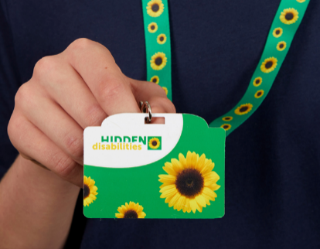
Floriade is part of the Hidden Disabilities Sunflower scheme.
You can wear the Sunflower at Floriade.
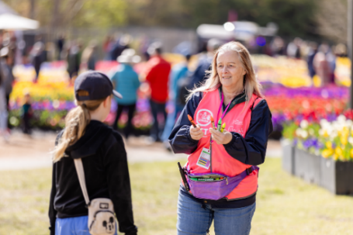
There are staff and volunteers who can help you with
- support you need
- adjustments you need.

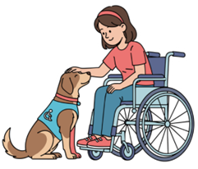
Assistance Animals
You can bring your assistance animal to Floriade.
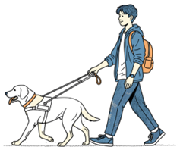
An assistance animal is trained to help you with a disability.
Assistance animals must have a lead on all the time.


Tickets
Most of Floriade is free.
Some activities need tickets.
You need to buy a ticket for NightFest.
You can buy tickets on the website: https://floriadeaustralia.com/nightfest/

Companion Card

To use your companion card, you must buy your own ticket first.
You must email us to ask for a companion ticket at events@act.gov.au
In the email you must send us
- The name of the person that bought your ticket
- The email address used to buy your ticket
- A photo of your companion card
We will then email the companion ticket
to you.

If you need help or more information
Staff and volunteers can help you at Floriade and NightFest.
All volunteers at Floriade wear pink vests.
Before you come to Floriade or NightFest you can

- email us at events@act.gov.au
- call the Canberra Region Visitor Centre on 1300 554 114 between 9:00am and 5:00pm.


If you need help with English
Call the free Translating and Interpreting Service. You can call in your language.
- Call 131 450
- Tell them the phone number you want to call

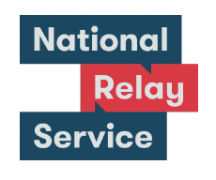
If you need help to speak or listen
Use the National Relay Service. You must sign up to the service first.
- Website
accesshub.gov.au/nrs-helpdesk
- Call 1800 555 660

Acknowledgement of Country
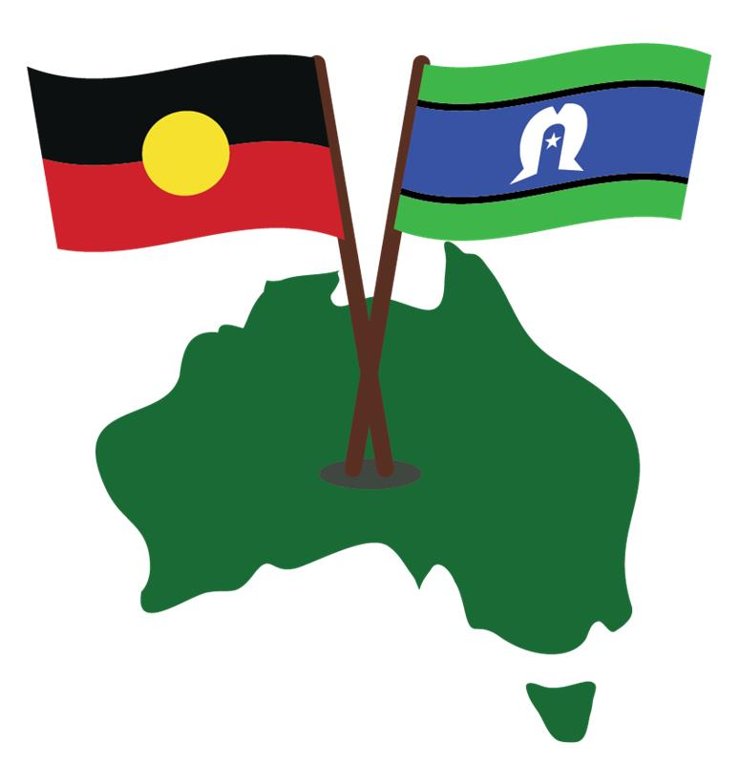
Aboriginal and Torres Strait Islander peoples are the First Peoples of Australia.
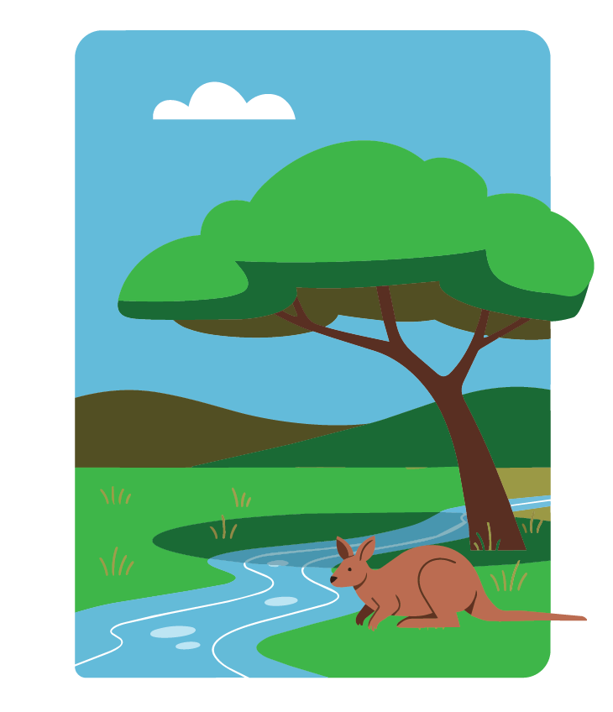
They have always looked after Country. Country means the land, water, sky and everything in them.
We respect the important connection they have with Country.
Events ACT created this Easy Read document in September 2026. Images used are with permission. Feedback for improvement is welcome.

