Floriade Accessibility Guide 2026
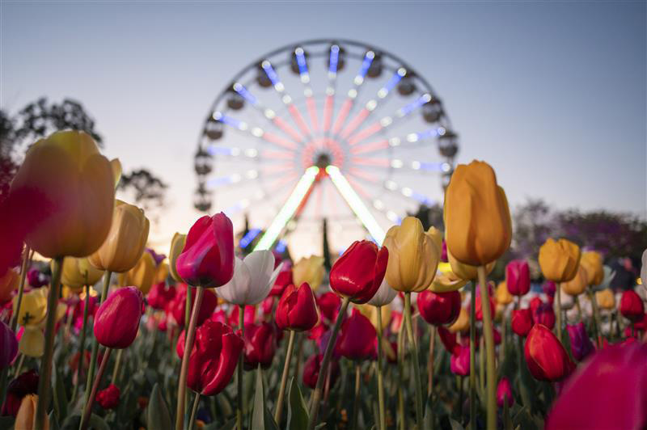

Floriade Accessibility Guide
You can use this guide to find out about accessibility services at Floriade. It will help you plan your visit.
Floriade is on at Commonwealth Park in Canberra.

Main accessibility services
- Accessible parking, drop-off zones, and free accessible shuttle buses
- Accessible toilets, including a Changing Places facility
- Mobility hire, including wheelchairs and electric scooters
- Sensory Hour on weekday mornings from 9:30am to 10:30am
- Sensory space next to the Floriade Shop
- Accessible gnome painting sessions for schools and community groups during Sensory Hour
- Accessible community and nursing home bus tours

Plan your visit

Floriade interactive map
BindiMaps is an accessible digital map of Commonwealth Park. You can use BindiMaps to find your way around Floriade.
With BindiMaps, you can:
- plan your visit from home
- get directions from your home to the Floriade gates
- get directions for walking, driving, cycling, public transport, or wheelchair friendly options
- find garden beds, food vendors, stages, market stalls, and facilities on the map
- receive real-time updates for road closures, shuttle bus information, and accessibility changes
- view information in multiple languages.
Use the Floriade interactive map.

Floriade site map
You can use the Floriade site map to find accessible facilities.
You can also use the map to find food, stages, market stalls and garden beds.
View the Floriade site map.

Getting to Floriade
Changes to bus routes, road access, and parking may affect your travel. This is due to ongoing light rail construction. Accessible transport options include the free Floriade Weekend Express Buses and the Floriade Daily Shuttle. Both are wheelchair accessible.

Floriade Bus services

Floriade Shuttle Bus
A free Floriade Shuttle Bus helps you get from carparks in the city and the National Triangle to the Floriade gates. It runs every day on a regular timetable.
The Floriade Shuttle Bus is wheelchair accessible.

See the Floriade Shuttle Bus map and timetable.

Floriade Weekend Express Bus
The free Floriade Weekend Express Bus helps you get from Belconnen, Tuggeranong and Woden to Floriade. It only runs on weekends, public holidays and during NightFest.
The Floriade Weekend Express Bus is wheelchair accessible.

See the Floriade Weekend Express Bus maps and timetables.

Accessible Parking
There are 35 free accessible parking near the Regatta Point Entry Gate (via Commonwealth Avenue). You must show a valid disability parking permit on your car. This includes permits from interstate or overseas.

Drop off zones
You can get picked-up and dropped-off at:
- Regatta Point entry gate
- Allara Street for the Parkes Way entry gate across the footbridge.
You cannot park in these zones.
Access to the Parkes Way entry gate is across the footbridge. Only use this drop off zone if you can use the footbridge.

Getting around Floriade
The path around Floriade is about 1.6 kilometres. The paths are sealed with bitumen or compacted gravel. Many of the entertainment and dining areas are on grass.
The Floriade train runs through the event and is a fun way to see the site.

Mobility Hire
You can hire a limited number of wheelchairs, walking frames, electric mobility scooters, and strollers on site.
To make a booking please
- email scooters@netspeed.com.au
or
- send a text message to 0403 242 584

Facilities

Accessible toilets
There are accessible toilets at Floriade. They are at:
- Ferry Gate
- Stage 88
- Main vista
All accessible toilets have handrails and standard swinging doors. Accessible toilets also have baby change tables and nappy disposal.

Changing Places facility
A Changing Places facility is available near First Aid. It has:
- an adult-sized, height-adjustable change table
- a ceiling-mounted hoist system
- a peninsula-style toilet
- space for two carers
- a safe, clean and private environment
- an automatic door with clear signage and controlled access (via First Aid)

Parent and Carer room
A Parent and Carer Room is available near First Aid. It has:
- a change table
- low seat for breast or bottle feeding
- microwaves to heat or sterilise equipment.
This room is not wheelchair accessible.
The Floriade Café team can also give you hot water for warming bottles. There are quiet areas in the park if you would like to feed your baby outdoors.

Sensory Space
There is a sensory space next to the Floriade shop for visitors to use at any time during Floriade.
The space is a calm, low-sensory environment with comfortable furniture, soft lighting and relaxing ambience.

Wheelchair adapted picnic table
There are wheelchair adapted picnic tables at Floriade.
Wheelchair adapted picnic tables at the Stage 88 dining area are on grass.
Wheelchair adapted picnic tables near the Floriade shop are on flooring.

Services and Programs

Sensory Hour
Sensory Hour runs from 9:30am to 10:30am on weekdays during Floriade. It does not run on weekends or public holidays.
During this hour there will be less amplified sound and no stage performances. This helps visitors with sensory needs.

Assistance animals
You can bring your trained and accredited assistance animals to Floriade.
You must keep your animal on a lead at all times.
Please note: you cannot bring pets and non-assistance animals to Floriade. You can only bring your pet dog on Sunday 11 October, for Dogs’ Day Out.

Hidden Disabilities
Floriade has joined the Hidden Disabilities Sunflower scheme. On site there are staff and volunteers trained to recognise the Sunflower and support the wearer with any adjustments they may need.

Accessibility Ambassadors
At Floriade Accessibility Ambassadors will be available to assist visitors with accessibility needs. They can help direct people to available facilities and services at Floriade.
The Accessibility Ambassadors will wear a dedicated lanyard and pass. They are here to help with a range of accessibility needs, including hidden disabilities.

Noise Cancelling Headphones
A limited number of noise-cancelling headphones are available for hire from the Information Hub in Main Vista.
These headsets are Designed to help reduce surrounding noise and can assist visitors who prefer a quieter sensory experience while exploring the event.
- Limited numbers available daily
- Available on a first-come, first-served basis
- Hire fee: $10

Accessibility and Sensory friendly signage
Look out for signage throughout the event to help identify:
- Low and high sensory areas
- Accessible facilities
- Sensory Space
- Changing Places facility
- Accessible pathways
- Inclines and declines

Gnome painting - accessible group bookings
You can book gnome painting sessions for schools and community groups with access needs. The sessions are at the Rotary Gnome Knoll on a Tuesday, Wednesday or Thursday of the first two weeks of Floriade.
They are open to all ages and abilities. Groups must provide their own supervision and support for safe participation.
To book, email events@act.gov.au.

Community and nursing home bus tours
Bookings for 2026 are now full.
These bus tours help aged care residents to see Floriade without leaving the vehicle.
Email events@act.gov.au to register your interest for future years.

NightFest Accessibility
NightFest is an accessible event. You can let us know about your needs by:
- emailing events@act.gov.au before the event
- talking to staff when you arrive at the event.
Accessibility facilities at NightFest are the same as at Floriade including:
- mobility hire
- accessible toilets
- a Changing Places facility
- a parent and carers room
- wheelchair adapted picnic tables.
Accessibility transport to NightFest is the same as at Floriade including:
- accessible parking
- accessible drop off and pickup points
- free Floriade Shuttle Bus from the city and National Triangle
- free Floriade Weekend Express Bus from Belconnen, Woden or Tuggeranong.

Companion Cards
We accept Companion cards at NightFest.
You need to buy your own ticket to NightFest first. You can then email events@act.gov.au to ask for your companion ticket.
In the email you need to include:
- the name of the person that bought your NightFest ticket
- the email address used to buy your NightFest ticket
- a photo of your companion card.
We will then email you the companion ticket for NightFest.

Accessible entry to NightFest
NightFest entry gates are at:
- Regatta Point
- Parkes Way footbridge
- Ferry Gate.
There is an accessible entry lane at all gates. These are for wheelchair users and people who cannot use the usual lines. There will be staff at these entry lanes you can talk to about your accessible entry needs.
Both Regatta and Parkes Way gates are near drop off and pick up zones. Access to the Parkes Way entry gate is across the footbridge. Only use this drop off zone if you can use the footbridge.

Accessibility at Lanyon Homestead, Floriade’s Satellite Site
Lanyon Homestead is Floriade’s official satellite site. This means it has flower beds on display and will have special events on during Floriade.
You can only get to Lanyon Homestead by car. There is no direct public transport to the site.
If you need help to get from the carpark to the homestead, a guest transport buggy is available. You can press the call button near the accessible parking spot in the main carpark.
Please tell us any accessibility needs you have when you book an event at Lanyon. A team member will contact you to talk about your needs.
If you have questions, you can email HistoricPlacesBookings@act.gov.au

Contact and feedback
Our staff and volunteers can answer your questions and help with your visit at Floriade.
For more information, email events@act.gov.au or call the Canberra Region Visitor Centre on 1300 554 114.

Continuous improvement
Floriade is always working to be more inclusive and accessible. If you have feedback or suggestions, please email events@act.gov.au.

